**END-TERM EXAM(A)**

Q1) Create the database schema for the Transport department using the given relations. Add primary key constraints and referential integrity constraints accordingly [2 Marks]

| **CREATE** **TABLE** Bus (  BusNo VARCHAR(10) PRIMARY **KEY**,  **Source** VARCHAR(50),  Destination VARCHAR(50),  CoachType VARCHAR(20) );  **CREATE** **TABLE** Ticket (  TicketNo VARCHAR(15) PRIMARY **KEY**,  DOJ DATE,  Address VARCHAR(100),  ContactNo VARCHAR(15),  BusNo VARCHAR(10),  SeatNo INT,  **Source** VARCHAR(50),  Destination VARCHAR(50),  FOREIGN **KEY** (BusNo) **REFERENCES** Bus(BusNo) );  **CREATE** **TABLE** Passenger (  PassengerID VARCHAR(10) PRIMARY **KEY**,  TicketNo VARCHAR(15),  **Name** VARCHAR(50),  ContactNo VARCHAR(15),  Age INT,  Sex CHAR(1),  Address VARCHAR(100),  FOREIGN **KEY** (TicketNo) **REFERENCES** Ticket(TicketNo) );  **CREATE** **TABLE** Reservation (  PNRNo VARCHAR(20) PRIMARY **KEY**,  DOJ DATE,  NoofSeats INT,  Address VARCHAR(100),  ContactNo VARCHAR(15),  BusNo VARCHAR(10),  SeatNo INT,  FOREIGN **KEY** (BusNo) **REFERENCES** Bus(BusNo) ); |
| --- |

Q2)Insert at least 5 tuples in each relation appropriately. (Note: If any table has records less than 5 you may lose your marks) [2 marks]

| **INSERT** **INTO** Bus (BusNo, **Source**, Destination, CoachType) **VALUES** ('BUS123', 'Delhi', 'Mumbai', 'AC'),  ('BUS456', 'Kolkata', 'Pune', 'Non-AC'),  ('BUS789', 'Bangalore', 'Hyderabad', 'AC'),  ('BUS321', 'Chennai', 'Mumbai', 'Non-AC'),  ('BUS654', 'Delhi', 'Kolkata', 'AC');  **INSERT** **INTO** Ticket (TicketNo, DOJ, Address, ContactNo, BusNo, SeatNo, **Source**, Destination) **VALUES** ('TICK001', '2022-10-10', '123 Delhi', '9876543210', 'BUS123', 1, 'Delhi', 'Mumbai'),  ('TICK002', '2022-10-10', '456 Kolkata', '8765432109', 'BUS456', 2, 'Kolkata', 'Pune'),  ('TICK003', '2022-10-09', '789 Bangalore', '7654321098', 'BUS789', 3, 'Bangalore', 'Hyderabad'),  ('TICK004', '2022-10-10', '321 Chennai', '6543210987', 'BUS321', 4, 'Chennai', 'Mumbai'),  ('TICK005', '2022-10-11', '654 Delhi', '5432109876', 'BUS654', 5, 'Delhi', 'Kolkata');  **INSERT** **INTO** Passenger (PassengerID, TicketNo, **Name**, ContactNo, Age, Sex, Address) **VALUES** ('PASS001', 'TICK001', 'Amit Sharma', '9876543210', 30, 'M', '123 Delhi'),  ('PASS002', 'TICK002', 'Rajesh Kumar', '8765432109', 25, 'M', '456 Kolkata'),  ('PASS003', 'TICK003', 'Priya Singh', '7654321098', 28, 'F', '789 Bangalore'),  ('PASS004', 'TICK004', 'Sana Khan', '6543210987', 12, 'F', '321 Chennai'), -- Minor  ('PASS005', 'TICK005', 'Rahul Mehta', '5432109876', 40, 'M', '654 Delhi');  **INSERT** **INTO** Reservation (PNRNo, DOJ, NoofSeats, Address, ContactNo, BusNo, SeatNo) **VALUES** ('PNR001', '2022-10-10', 1, '123 Delhi', '9876543210', 'BUS123', 1),  ('PNR002', '2022-10-10', 2, '456 Kolkata', '8765432109', 'BUS456', 2),  ('PNR003', '2022-10-09', 1, '789 Bangalore', '7654321098', 'BUS789', 3),  ('PNR004', '2022-10-10', 3, '321 Chennai', '6543210987', 'BUS321', 4),  ('PNR005', '2022-10-11', 1, '654 Delhi', '5432109876', 'BUS654', 5); |
| --- |

Q3) Write an SQL query that finds the PNR NO. and Number of seats in each where the date of journey is 10th Oct 2022. [2.5 marks]

| **SELECT** PNRNo, NoofSeats **FROM** Reservation **WHERE** DOJ = '2022-10-10'; |
| --- |

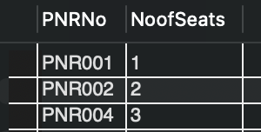

Q4) Write an SQL query to retrieve a list of passengers who are classified as minors. (Ensure that your table contains at least one minor passenger). [2.5 marks]

| **SELECT** PassengerID, **Name**, Age **FROM** Passenger **WHERE** Age < 18; |
| --- |

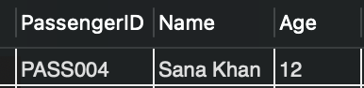

Q5) Write an SQL query to find the number of passengers traveling from the same source to destination on a specific date. [2.5 marks]

| **SELECT COUNT(*) AS NumPassengers, Source, Destination, DOJ**  **FROM Passenger P**  **JOIN Ticket T ON P.TicketNo = T.TicketNo**  **GROUP BY Source, Destination, DOJ;** |
| --- |

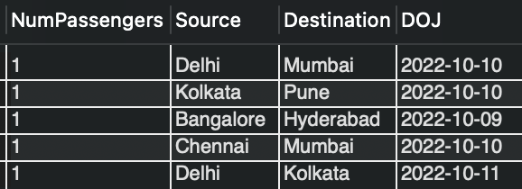

Q6)Sort the passenger details according to their name (print only unique details, discard if any duplicate names are there.) [2.5 marks]

| **SELECT** **DISTINCT** **Name**, Age, Sex, Address, ContactNo **FROM** Passenger **ORDER** **BY** **Name**; |
| --- |

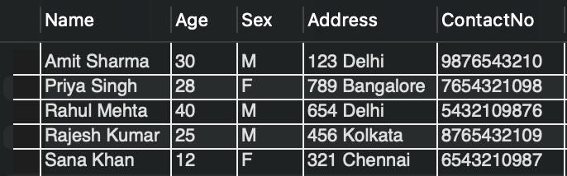

Q7)Create a view CancelTickets (TicketNo, Pnr No.) for the schema [3 marks]

| **ALTER TABLE Ticket**  **ADD Status VARCHAR(9);**  **UPDATE Ticket**  **SET Status = 'Confirmed'**  **WHERE TicketNo IN ('TICK001', 'TICK002', 'TICK003');**  **UPDATE Ticket**  **SET Status = 'Cancelled'**  **WHERE TicketNo IN ('TICK004', 'TICK005');**  **CREATE VIEW CancelTickets AS**  **SELECT TicketNo, PNRNo**  **FROM Ticket T**  **JOIN Reservation R ON T.BusNo = R.BusNo**  **WHERE Status = 'Cancelled';** |
| --- |

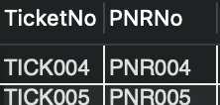

Q8) Write an SQL procedure to display the passengers' booking history. [4 marks].

| **CREATE** **PROCEDURE** BookingHistory() **BEGIN**  **SELECT** Passenger.Name, Ticket.TicketNo, Ticket.DOJ, Ticket.Source, Ticket.Destination, Bus.BusNo  **FROM** Passenger  **JOIN** Ticket **ON** Passenger.TicketNo = Ticket.TicketNo  **JOIN** Bus **ON** Ticket.BusNo = Bus.BusNo  **ORDER** **BY** Ticket.DOJ **DESC**; **END** // |
| --- |

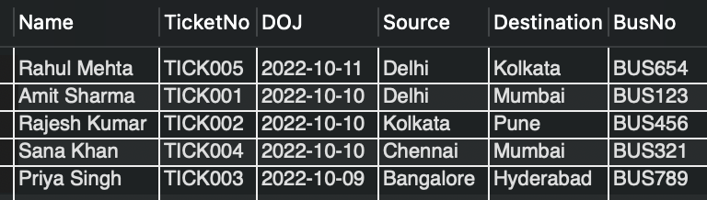

Q9)Write a query to retrieve the names and contact numbers of all passengers who have reserved seats on a specific bus (BusNo = 'BUS123') along with the seat number and destination. [4 marks]

| **SELECT** Passenger.Name, Passenger.ContactNo, Ticket.SeatNo, Ticket.Destination **FROM** Passenger **JOIN** Ticket **ON** Passenger.TicketNo = Ticket.TicketNo **WHERE** Ticket.BusNo = 'BUS123'; |
| --- |

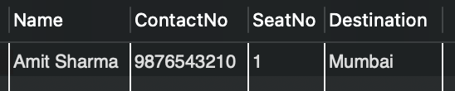

**Assumptions:**

* Each ticket is associated with one passenger.
* Status of tickets is either 'Confirmed' or 'Cancelled'.
* Some PNR numbers may have multiple tickets linked.